**Name :Esha Shahzad**

**Sap#5593**

**COAL LAB#3**

**Task#1 Print is**

model small

.stack 100h

.data

.code

main proc

mov dl,'i'

mov ah,2

int 21h

mov dl,'s'

mov ah,2

int 21h

mov ah,4ch

int 21h

main endp

end main

**output:**

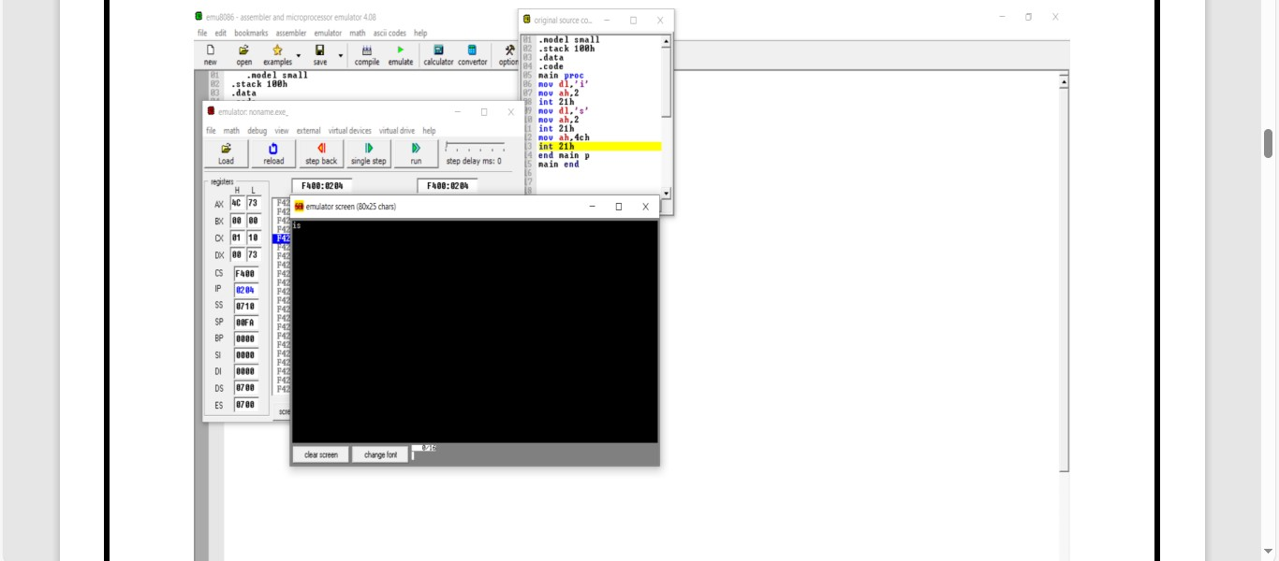

**Task#2 print your name:**

.model small

.stack 100h

.data

.code

main proc

mov dl,'E'

mov ah,2

int 21h

mov dl,'s'

mov ah,2

int 21h

mov dl,'h'

mov ah,2

int 21h

mov dl,'a'

mov ah,2

int 21h

mov dl,10

mov ah,2

int 21h

mov dl,13

mov ah,2

int 21h

mov dl,'S'

mov ah,2

int 21h

mov dl,'h'

mov ah,2

int 21h

mov dl,'a'

mov ah,2

int 21h

mov dl,'h'

mov ah,2

int 21h

mov dl,'z'

mov ah,2

int 21h

mov dl,'a'

mov ah,2

int 21h

mov dl,'d'

mov ah,2

int 21h

int 21h

main endp

end main

**Output:**



**Task#3: Write a program that input a character from user is in lowercase, the program will convert it to uppercase and will display it on console after conversion.**

.model small

.stack 100h

.data

.code

main proc

mov ah,1

int 21h

mov dl,al

sub dl,32

mov ah,2

int 21h

mov ah,4ch

int 21h

main endp

end main

**Output:**

